Welcome to the Cloud Native CI/CD lesson!

Once a team has built a product and has structured a release process onto the platform, the next phase is to bring automation. A release process should enable a team to deliver new features to consumers, and it should be highly automated to eliminate misconfiguration scenarios. These functionalities are encapsulated by a CI/CD pipeline, for continuous integration and delivery of the new code changes.

In this lesson, we will explore how to use cloud-native tooling to construct a CI/CD pipeline. As well, we will explore template configuration managers, such as Helm to enable the easy deployment of an application to multiple clusters.

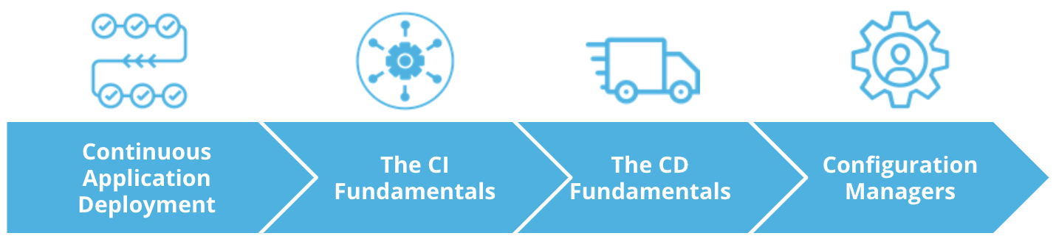

Cloud Native CI/CD lesson outline

Overall, in this lesson we will explore:

* Continuous Application Deployment
* The CI Fundamentals
* The CD Fundamentals
* Configuration Managers